MIT Assignment-08

Jeetu Mehra
U24AI032

1 | Write a Program to count continuously in hexadecimal from FFH to 00H in a system with 0.5μs cock period. Use register C to set up a one milisecond delay between each count and display the numbers at one of the output port. MVI A, 00H  LOOP: OUT 01H  CALL DELAY  DCR A  CPI 0FFH  JNZ LOOP  OUT 01H  HLT  DELAY: MVI C, 00H  D1: NOP  NOP  DCR C  JNZ D1  RET  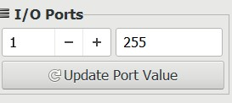

2 | Write a program to count from 0 to 9 with a one second delay between each count. At the count of 9,the counter should reset itself to 0 and repeat sequence continuously. Use register pair HL to set up the delay,and display each count at one of the output port. Assume the clock frequency of the microprocessor is 1 MHz.  ; Program to count 0-9 with 1 second delay  ; Clock Frequency: 1 MHz  ; Port: 01H (Assumed)  ORG 0000H  START: MVI C, 00H ; Initialize register C as the counter (0)  DISPLAY:MOV A, C ; Move the current count to Accumulator OUT 01H ; Output the count to Port 01H  ; --- 1 Second Delay Subroutine using HL Pair ---  LXI H, A2C2H ; Load HL with A2C2H (calculated for 1s)  DELAY: DCX H ; Decrement HL pair (6 T-states)  MOV A, L ; Move L to A (4 T-states)  ORA H ; OR with H to check if HL = 0 (4 T-states)  JNZ DELAY ; If not zero, jump back to DELAY (10 T-states)  ; -----------------------------------------------  INR C ; Increment the counter  CPI 0AH ; Compare Accumulator with 10 (0AH)  MOV A, C ; Move C to A for comparison  CPI 0AH ; Check if count has reached 10  JZ START ; If count is 10, reset to 0  JMP DISPLAY ; Otherwise, display the next number

3 | 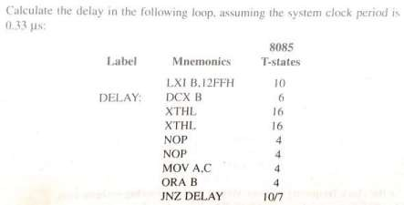  Given:  Clock period = 0.33 μs  LXI B,12FFH → 12FFH = 4863 (loop count)  T-states per iteration:  DCX B (6) + XTHL (16) + XTHL (16) + NOP (4) + NOP (4) + MOV A,C (4) + ORA B (4) + JNZ (10)  = 64 T-states  Last iteration:  JNZ = 7 instead of 10 → 64 - 3 = 61 T-states  Total T-states:  = (4862 × 64) + 61 + 10  = 311168 + 61 + 10  = 311239 T-states  Total delay:  = 311239 × 0.33 μs  ≈ 102709 μs  ≈ 102.7 ms  Final Answer: 102.7 ms

4 | 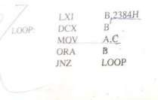  Given:  Clock period = 0.33 μs  LXI B,2384H → 2384H = 9092 (loop count)  T-states:  LXI B = 10  DCX B = 6  MOV A,C = 4  ORA B = 4  JNZ = 10 (jump), 7 (last)  T-states per iteration:  = 6 + 4 + 4 + 10  = 24 T-states  Last iteration:  = 24 - 3 = 21 T-states  Total T-states:  = (9091 × 24) + 21 + 10  = 218184 + 21 + 10  = 218215 T-states  Total delay:  = 218215 × 0.33 μs  ≈ 72010 μs  ≈ 72.0 ms  Final Answer: 72.0 ms
5 | A number is stored in memory location XX50H .Write a program to  1. Transfer the number from memory locations to A 2. Store a result at output port 02H  LXI H,2650H  MOV A,M
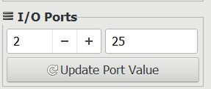
OUT 02H

HLT

Write a subroutine to
- To find 2’s complement of a number stored in A
- Return
COMP: CMA
INR A
RET

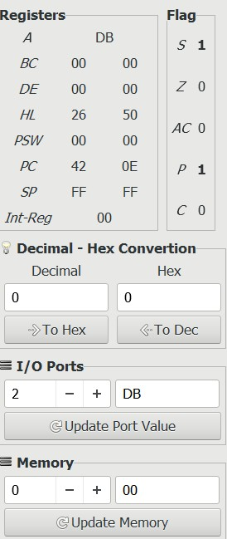

6 | . Write a program to  - Take number from input pot 1 and Transfer the numbers to A  - Take another a number from memory location 2000H. 3. Store a result at output port 02H  MVI A,34H  STA 2000H  IN 01H  MOV B,A  LDA 2000H  ADD B  OUT 02H  HLT

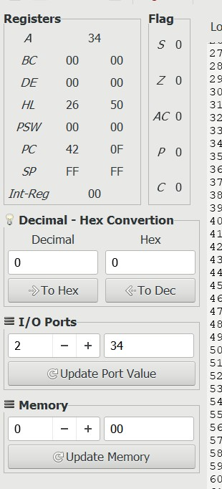

Write a subroutine to 1. Add both numbers
2. Return .
MVI A,34H
STA 2000H

IN 01H
MOV B,A

LDA 2000H

CALL ADDR

OUT 02H
HLT

ADDR: ADD B
RET

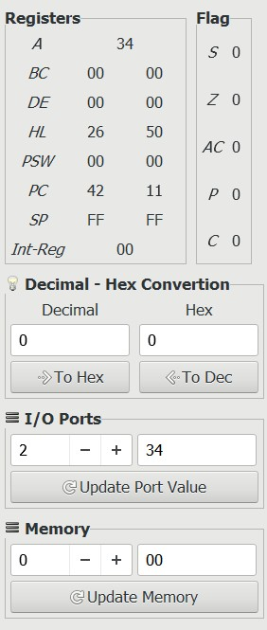

7 | 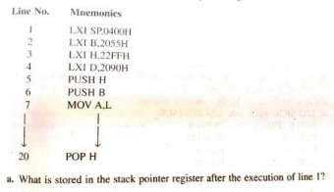  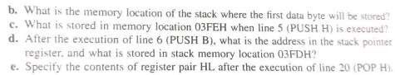  - SP after line 1  SP = 0400H  - First data byte stored location  - PUSH decreases SP first  SP → 03FFH (first location used)  - Value at 03FEH after PUSH H H = 22H, L = FFH Execution:  - SP → 03FF → store H (22H)  - SP → 03FE → store L (FFH)  Memory[03FEH] = FFH  - After PUSH B B = 20H, C = 55H Current SP = 03FEH Execution:  - SP → 03FD → store B (20H)  - SP → 03FCH → store C (55H)  SP = 03FCH  Memory[03FDH] = 20H

(e) After POP H (line 20) Stack currently:
Address Value
03FC 55
 | 03FD | 20
 | 03FE | FF
 | 03FF | 22
POP H:
- L ← 55 (from 03FC)
- H ← 20 (from 03FD)
HL = 2055H

8 | A multiplicand is stored in memory location XX50H and a multiplier is stored in location XX51H. Write a program to  - Transfer the two numbers from memory loations to HL pair  - Store a product at output port 02H  MVI A,05H  STA 2650H  MVI A,03H  STA 2651H  LHLD 2650H  MOV B,L  MOV C,H  MVI A,00H

LOOP: ADD B
DCR C
JNZ LOOP

OUT 02H
HLT

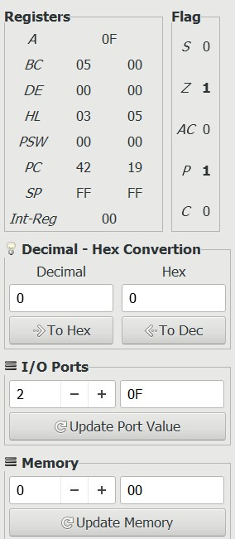

Write a subroutine to
- Multiply numbers stored into HL pair
- Return the result to HL pair
MVI A,05H

STA 2650H
MVI A,03H
STA 2651H

LHLD 2650H

CALL MUL

MOV A,L
OUT 02H
HLT

MUL: MOV B,L
MOV C,H
MVI A,00H

LOOP: ADD B
DCR C
JNZ LOOP

MOV L,A
MVI H,00H
RET

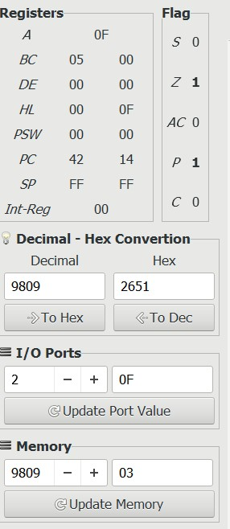
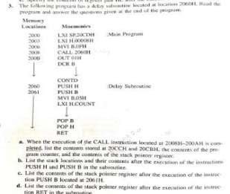
9

(
a) After CALL execution

Initial:

SP = 20CDH

Return Address = 200BH

→ High = 20H, Low = 0BH

Execution:

SP → 20CCH → store 20H

SP → 20CBH → store 0BH

Answer:

(20
CCH) = 20H

CBH) = 0BH
(20

PC = 2060H

SP = 20CBH

(
b) After PUSH H and PUSH B

PUSH H (H=00, L=00)

SP → 20CA → store H (00)

SP → 20C9 → store L (00)

PUSH B (B=0F, C=?? assume 00)

SP → 20C8 → store B (0F)

SP → 20C7 → store C (00)

Stack:

20
CCH → 20H

20
CBH → 0BH

20
CAH → 00H

20
C9H → 00H

20
C8H → 0FH

20
C7H → 00H

(c) SP after PUSH B (line 2061H)
SP = 20C7H
(d) After RET POP sequence:
- PCL ← 0BH
- PCH ← 20H
SP moves:
20C7 → 20C8 → 20C9 → 20CA → 20CB → 20CC → 20CD Final SP = 20CDH

